Likelihood of Bird Sightings in Presence vs. Absence of Observers
Homer-Center High School
2023 AP Bio Class
Grade 12
Caitlyn B.
Pennsylvania, USA

Introduction -

The AP Biology Class at Homer-Center High School is investigating the frequency of bird visits to a bird feeder based on the presence or absence of humans. There have been several other studies that have looked into the effect of humans on birds and how tolerant birds are becoming to human presence. UW News Staff states how “reduction in noise. . .from pandemic. . .allowed them [birds] to use a wider range of habitats in cities.” A similar experiment to ours was done by ScienceDirect. They found that birds were present 42% of the time when humans were there, and 72% present when humans were absent (Burger, 2003). Another study performed in 2006 investigated how human activity could be causing certain birds to be going extinct (Duke University, 2006). It is clear that the human effect on birds can vary from birds being tolerant and coexisting well with humans to being negatively affected by human activity. Our experiment will include observations of the number and frequency of birds at the feeder from both inside the classroom and outside. Our hypothesis is that birds will visit the feeder more frequently when we observe from inside the classroom than when we observe them in person.
We are based in Western Pennsylvania, the areas in which we were in the presence of birds include two wooded areas, one near a stream and away from any high traffic areas, the other was still in the wooded area, but in proximity to a highway and had higher noise levels. We also observed two other feeders in the presence of birds, one in a high traffic area in the open and the other a lower traffic, open area, but in proximity to a highway. The last feeder in which we observed the birds without any physical presence was in a low traffic, low noise, open area.
We conducted the study over a two day period, the 9th and 10th of May, 2023.

Method-

Our method to conduct this experiment was simple. We set up several bird feeders with Pennington’s Wild bird feed out in 4 varying locations. We went out multiple times with each student having a different task. These tasks included photographing birds that were sighted, identifying the birds that came and visited the feeders, and counting the number of birds that appeared. We spent the same amount of time at each feeder each time we visited them to make our observations and data as accurate as possible.

-

 | High Traffic  Open Area | Low Traffic Open Area | High Noise Wooded Area | Low Noise Wooded Area | Low Traffic, Low Noise, Open area*
Robin | lll | llll. l | llll. l | llll | llll.
Starling | llll. | llll. ll | llll. | lll | llll. lll
BlueJay | l |  | l | l | ll
Cardinal | ll | l | lll | lll | l
Song Sparrow | lll | lll | lll | l | llll
Chipping Sparrow | ll | llll. | lll | ll | lll
House Sparrow | llll. l | llll. llll. llll. ll | llll. | lll | llll. l
House Finch | l | lll | lll | ll | ll
Northern Mockingbird |  | l |  |  | lll
Grackle | llll. | lll | llll | llll | llll. llll. l
Gray Catbird |  |  | ll |  | ll

* - indicates feeder was observed without human presence

At each of the different feeder locations, we sat about thirty feet away from the feeder, made sure to sit still and keep noise levels low so as to not scare away any birds, and observed for about 40 minutes at each bird feeder. The last feeder was observed without human presence, and we did so by observing the feeder through a classroom window that sat above the feeder and did so for about 40 minutes.
On average, data showed a trend of more birds being observed when there was no active human presence. Because birds are so sensitive to motion, despite being about thirty feet from the feeder, if there was just a little bit too much motion, it would scare any birds away. As a result, when we were further away and out of sight of the feeder, more birds appeared and were more likely to be attracted to the food.

Conclusion-

Through the data collected, we saw that without human presence, birds are more likely to approach and feed from a bird feeder. But, even with human presence, there were still a considerable number of birds observed. This shows that birds have, over time, become more desensitized to human activity, but human activity still has some effect on where birds will feed from and nest. Based on this conclusion, we can infer that as the human population grows and we continue to expand, human activity could have a negative impact on bird populations. Human activities could and have been disrupting bird activity, displacing and forcing relocation on birds. Eventually, though, birds could become more comfortable with humans and we could see a continual rise in the number of birds living in urban and residential areas. On the contrary, we could also see the data remain stagnant or see a decrease in the number of birds in urban areas.
If this study is continued, we could continue to observe the birds in proximity to humans and look for a change in the number observed that indicates a change in behavior. Look for either an increase or decrease of birds appearing in presence versus absence of humans and then look for a likely cause, such as urban expansion or deforestation, and analyze how the data is connected and search for possible solutions to any problems with bird populations the data may present.
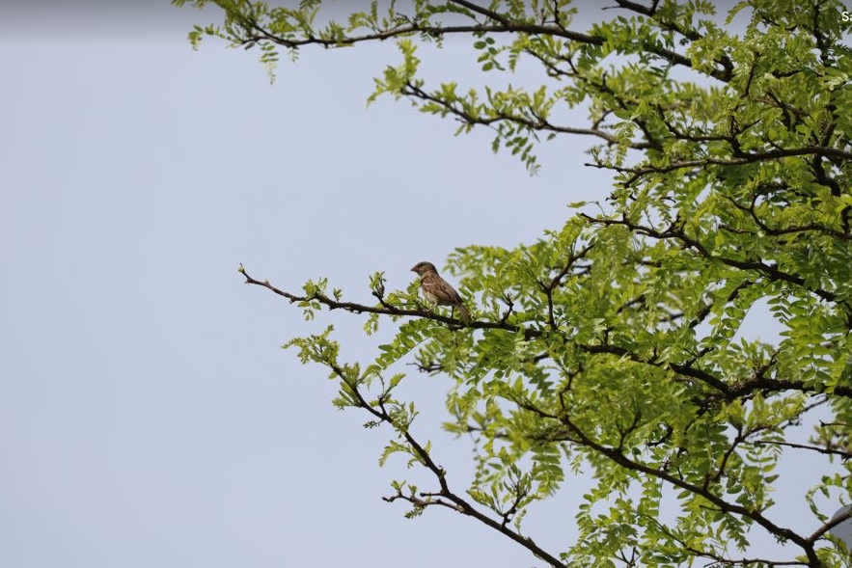
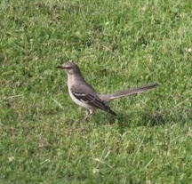
Photos-

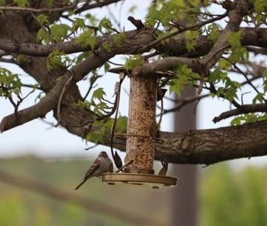
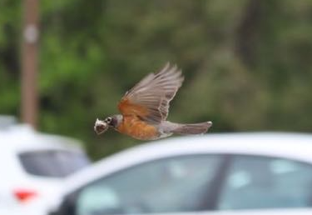

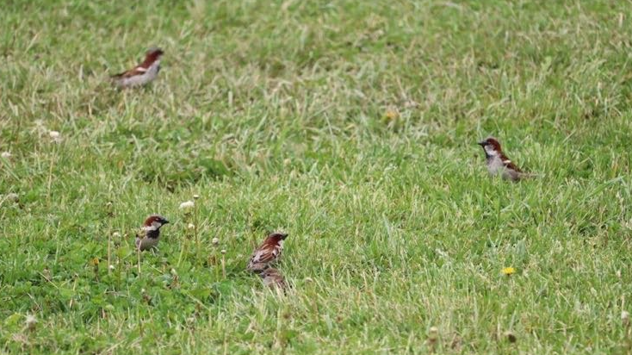

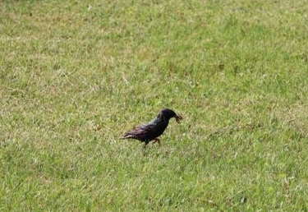

References

UW News Staff. (2022, August 11). Bird behavior influenced by human activity during COVID-19
lockdowns. University of Washington. https://www.washington.edu/news/2022/08/11/bird-behavior-influenced-by-human-activity-during-covid-19-lockdowns/

Burger, J. (2003, June 25). The effect of human activity on birds at coastal bay. Biological \
Conservation, 21(3), 231-241.
https://www.sciencedirect.com/science/article/abs/pii/0006320781900926

Duke University. (2006, July 5). Birds Face Extinction Risk Due To Human Activities. Mongabay.
https://news.mongabay.com/2006/07/birds-face-extinction-risk-due-to-human-activities/

